Johann Jakob Wolfensberger (1797-1850)

He was a gifted painter in water-colors, who mostly worked for the Nobles in Italy, Greece, and in the mediterranean region. He was also a scholared archaeologist. He painted the objects so ingenious and choosed the background so well that he is still today in Italy highly estimated, because he reports the earlier status of the articfacts in a unique manner.

He painted e.g. the temple of Jupiter Olympius with Akropolis in Athen, the temple of Neptun, the Forum Romanum in Rome. He was very busy between 1817-1843.

As an example here in a thumbnail the temple of Jupiter with the Akropolis in the background:

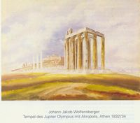

If you are interested for more about this ancestor I could tell you the whole story for the Newsletter – but give me time for this.

Rudi Wolfensberger, Solothurn

